JIM PREPARATORY NURSERY & PRIMARY SCHOOL
IKI-IKI
MOTTO: OUR GOD IS ABLE
TERM TWO ASSEAAMENT EXAMS SET V 2023
PRIMARY ONE
ENGLISH LANGUAGE
DURATION: 2HRS 15 MIN
NAME: ..................................................................................
STREAM:..............................................................................

INSTRUCTIONS:

1. Read well and answer all questions.
2. You must write well.
3. Write correct spellings.

SECTION A

Fill in the missing letter .
1. te__cher
2. e__rs
3. docto__
Write the words in brackets correctly.
4. That _____________ is big . (manwo)
5. I can not see my __________ . (bkoo)
6. This is a ________ . (tma)
7. My _________ is short . (cilpen)
Give the plural .
one many
8. boy ___________
9. bag ___________
10. goat ___________

Write a small word .
11. classroom ________
12. near ________
Write in ABC order .
13. e, d, f
_______________
14. duster, book, father
______________________________
15. matron, baby, cook
______________________________

Circle the correct word.
16. father, fahter, fathar

17. bleta, table, lebta

Use the given words to complete the sentences.
( are , is , an , am )
18. I ______ a good girl .
19. Tom has ________ orange .
20. These _______ pens .
Fill in the gaps with a correct word.
21. I sit ______ a chair .
22. Tom is pointing _______ the sun .
23. I am _______ Primary One class .
24. Sarah has a book ________ a pencil.

Study the pictures and complete the sentences correctly.
25. 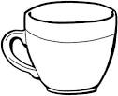
These are _________ .

26. 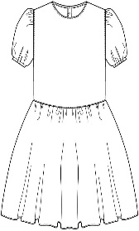 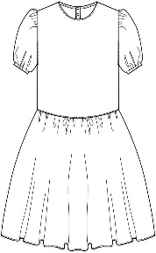 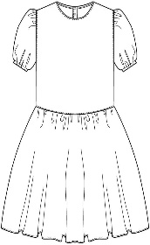
I can see three _________ .
27. 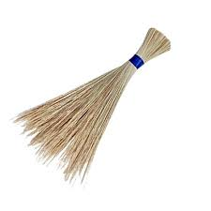
They are big _________ .

28.  These are two __________ .

Arrange the words to make a correct sentence .

29. boy is a He .
____________________________
30. eating food I am .
____________________________
Give the opposite .

31. small ______________
32. good ______________
33. mother ______________
Write the number in words.
34. Tom has _________ books . 2
35. I saw _______ chairs . 6
36. There are _________ pencils in the tin . 4
37. A week has _________ days . 7
Match and make a correct word .
38. class board _______________
39. chalk keeper _______________
40. shop room _______________

Answer Yes, it is . or No, it is not .
41. Is this a chair ?
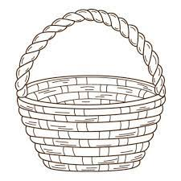 _______________
42. Is this a cup ?
_______________

43. Is this a dog ?
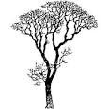 ______________
44. Is this a pot ?

_______________

45. Is this a house ?
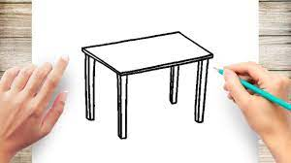 ______________

Write one word for many .
( colours, numbers, clothes, food, animals )

46. one, two, three ____________
47. skirts, sweaters, dresses ____________
48. cows, goats, monkeys ____________
49. red, blue, black ____________

50. maize, posho, cassava ____________

SECTION B
51. Read the story below and answer the questions about it.
CAT
There is a cat at home. Its name is Bepe. Bepe is happy. It eats meat and rats. Bepe drinks milk. It does not like grass. People at home like it so much .
Sarah
Primary One

Questions.
(a) What is there at home ?
___________________________________________
(b) What is its name ?
___________________________________________
(c) Write the title of the story.
___________________________________________
(d) What does it eat ?
___________________________________________
(e) Who likes it so much ?
___________________________________________
(f) In which class is Sarah ?
___________________________________________
(g) What does Bepe drink ?
___________________________________________
(h) Who wrote the story ?
___________________________________________
(i) Give the plural .
cat __________
rat __________

52. (A) Use the correct word to complete the
sentences.
( under, over, behind, on, near, in )
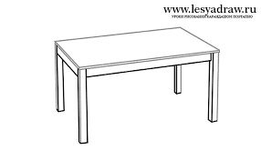

(i) The snake is ________ the table .
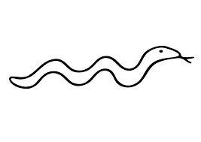

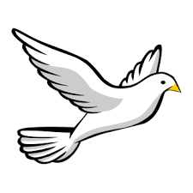

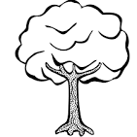
(ii) The bird is flying ________ the tree .

(iii) The cup is ________ the chair .
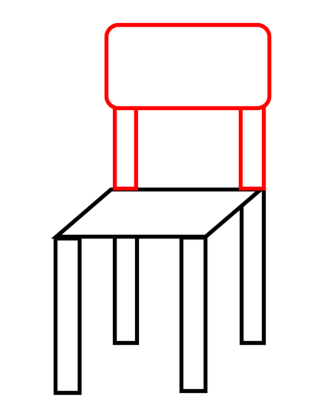
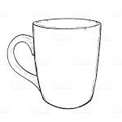

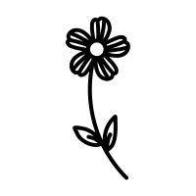
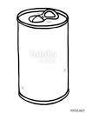

(iv) The flower is _______ the tin .

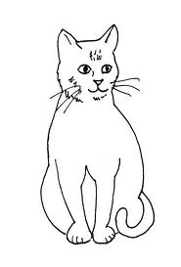
(v) The cat is _______ the table .

(B) Use the words in the box to complete the story
correctly.

My body is so nice. I have two 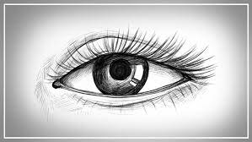 ________ for seeing. A 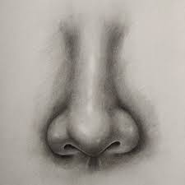 __________ for smelling . Two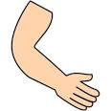 _________ for touching. My 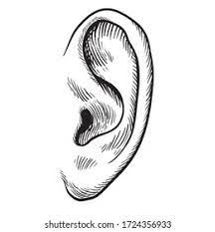________ for hearing. Long 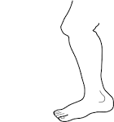 _________ for walking and a very nice head with black hair.

53. Read the dialogue and answer questions correctly.

John : Hullo, Mary.
Mary: Hullo, John.
John : Why are you sad ?
Mary: I cut my finger with a knife .
John : Oh sorry , go to the sickbay.
Mary: Thank you .

Questions.

(a) Who spoke first ?
_________________________________________
(b) How many people are talking ?
_________________________________________
(c) What cut Mary’s finger ?
_________________________________________
(d) Where should Mary go ?
_________________________________________
(e) Who was sad ?
_________________________________________

END

